Dynamic Program Name Builder

Where does it live in Marketo?

**The JSON maintenance document**

Design Studio -> Name Generator -> Files/Assets -> Name Generator -> NameGeneratorJSON.json

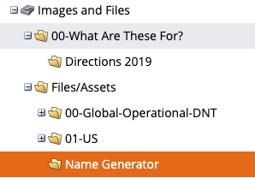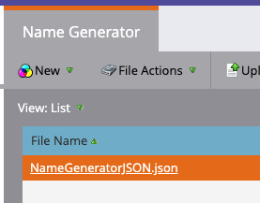

This will be your primary JSON maintenance document which enables you to make the dynamic changes without going into any code.

The best practice is to save this file off locally, apply the changes to it locally and then delete the current NameGeneratorJSON.json file and then re-upload your locally changed file. It will take a couple mins for the changes to occur – so it’s good to be a little patient here and refresh the page a couple of times. Marketo will cache the old file for a couple mins.

**The Dynamic Program Naming Builder Landing Page**

Marketing Activities -> Active Marketing Programs -> 00 Program Name Builder -> Program name -> Program Name Builder LP -> Click View APPROVE Page

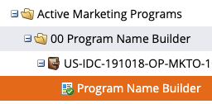

In the Landing Page itself -> there is a HTML element which contains the engine that renders the web form based off of the JSON maintenance document. 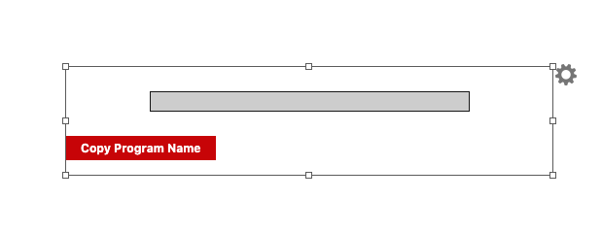

What can it do for me?

* Field Labels - the friendly values of the form inputs
* Fields Keys(the program output values) - the program output that would appear in the textbox - i.e (United States - US)
* Field Order - Straight forward what order the fields appear.
* New field creation - Creating a new input field
* Field deletion - getting rid of old data
* Field datatypes (dates,text,picklists etc.)
* Picklist value order (order of options in a picklist)
* Program Name output order (Where the output values appear in the name)
* Program Name delimiter (How are we delimiting the program keys in the program out?)
* Dynamic picklist dependency (This is advance functionality*)

How to use JSON maintenance document

It’s first good to understand how JSON format works in general. This is a specific universal data format. It is important that the structure is consistent for it work.

I recommend copying and pasting your JSON into <https://jsonlint.com/> and then hit ‘Validate JSON’ – this will let you know if the JSON is correct or show you where the error is.

**Terminology:**

1. Field Object – The fields that are being rendered as well as how they are rendered
2. Option Object – Inside of picklist there are options for picklists. These objects show how they are rendered.

**Add a new picklist field:**

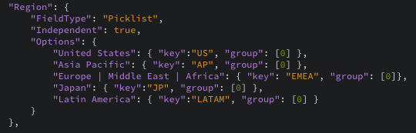

Look for any field object with a ‘FieldType’ of Picklist. Copy this and use this as a model, paste this anywhere depending on where you want it to appear on the form.

In this model here -> Change “Region” to be the desired value for the label of your field.

Under “**Options**” dictates the friendly labels of the values a person can choose.

For example: “United States”

You can also set the **key** which would appear in the Program output name.

For example: “US”

**Options -** Feel free to delete option objects, add or modify. The order they appear in this JSON is the order they will appear in your picklist.

**group –** If you want to disable an option from appearing and not delete it. Take the zero out of the brackets.

Make sure if the option is not the last it has a comma at the end. Notice “Japan” has a comma at the end where “Latin America” does not. The JSON validator will catch this as well.

**Add a new text field:**



Look for any field object with a ‘FieldType’ of Text. Copy this and use this as a model, paste this anywhere depending on where you want it to appear on the form.

In this model here -> Change “Program ID” to be the desired value for the label of your field.

**Add a new date field:**

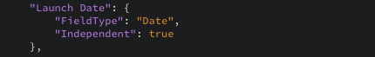

Look for any field object with a ‘FieldType’ of Date. Copy this and use this as a model, paste this anywhere depending on where you want it to appear on the form.

In this model here -> Change “Launch Date” to be the desired value for the label of your field.

**Delete any field:**

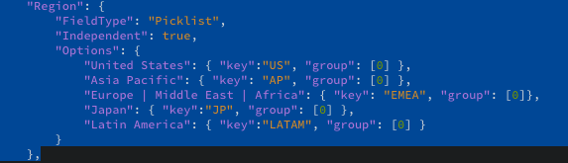

Deleting a field is straight forward, just highlight the entire field object including the comma at the end and hit backspace! This is the same for all fieldtypes.

**Change any field order:**

Changing a field is just cutting one field object and pasting it somewhere else in the document for the position you want it in.

For example:

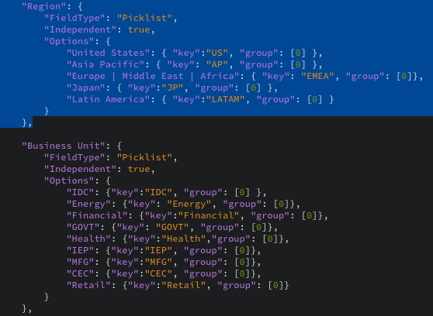

If I want ‘Region’ field object to appear underneath ‘Business Unit’ field object – then I just highlight all of the ‘Region’ field object, cut it and then paste it below ‘Business unit’ field object.

**Configuration of the Output Name:**



The last ‘field object’ in this JSON maintenance document is this Configuration object. This object dictates out the field keys are delimited in the output name. It also dictates the order of the keys as well.

“OutputDelimiter”: “-“ - this value puts ‘-‘ in between each field key for the final output name to be copied to the new program.

“OutputFormat”: If you want the keys to appear in a certain order, switch the friendly labels of the fields around in this array.

**Dynamic Picklist Dependency**

In all of the picklist example you may of seen option objects with a “group” field in them.

This means there is 1 field object based off the selection will show/hide any other picklists values in other picklists.

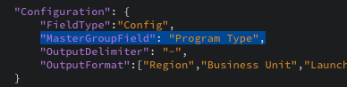

In Our Configuration field object, there is a field called “MasterGroupField” – this determines the field object that the other picklists are looking at when deciding what values to show.

In this example – “Program Type” is the master group field.

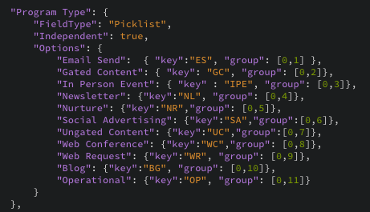

If we take a look at “Program Type” field object. We can see in the picklist Option objects in the group section – there are values such as [0,1], [0,2] etc.

The 0 – means it will display it in the picklist no matter what.

The other number (> 0) is this option’s main key

Ok now if we take a look at a field object where “Independent” is false, such as “Program Type Detail” in our example model.

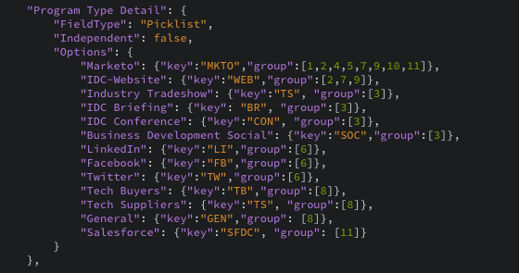

You can observe that these group’s have various numbers in them. Take a look at the option object: “IDC-Website”

The “group” field has [2,7,9] in it.

This means this option will only show in the “Program Type Detail” picklist if the main key of “Program Type” selected was either 2,7 or 9.



“Gated Content”, “Ungated Content” and “Web Request” will be the ONLY visible options for “Program Type” picklist when this is rendered on the webpage.

Examples